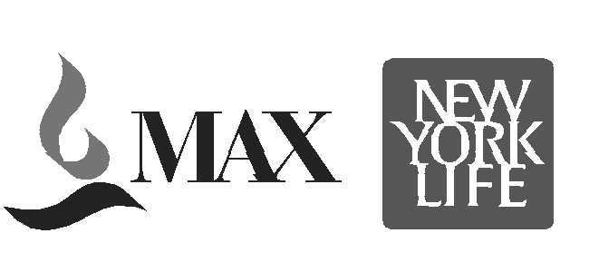 Form ‘E’
MAX NEW YORK LIFE INSURANCE CO. LTD.

Home Office: - Gurgaon General Office……………

CERTIFICATE BY EMPLOYER
With respect to claim under Policy No…………………………on the life of ………...
…………………………………….. I hereby make the following statement:

1. a) Name of the deceased ……………………………………………….
b) Date of Birth (as per records) ………………………………………………….
c) Address of the deceased ………………………………………………….
……………………………………………………….
d) Date & Time of Death …………………………………………………
e) Cause of Death ….……………………………………………….
f) Place of Death ……………………………………………………..
g) Nature of Duties ……………………………………………….
h) Date of joining ……………………………………………………….

2. a) Date on which the deceased last attended duties ……………………….
b) First complaint of illness by deceased ……………………….
c) Date of immediate absence from duties ……………………..

3. Nature and Duration of leave (Please state nature of leave availed of i.e. Casual, Earned, Sick etc. during the past three years. If sick leaves are taken and medical certificates are produced send copies of leave applications and certificates. Please let us know the details of Medical reimbursement claimed from your organization.)

Please attach separate sheet for Sick Leave / Medical leave availed in the last 3 years
Nature of Leave | Effective Date- Commencement | Effective Date- resuming duties | Total Duration of Leave availed

Signature of Witness……………………. Signature of Employer……………………

Name of Witness………………………... Name & Designation………………….…
Address…………………………………. Address……………………………………
Date……………………………………... Date…………………………………….….
Telephone number with STD code…………Telephone number with STD code ……..

Company Seal……………………………

Witness should neither be a relative of the deceased nor a claimant under the policy.

